DMM B18 V1.0 App

Quick Guide



Address: 125, Mahajan Society, B/H Convent School, Fatehgunj,

Vadodara - 390002, Gujarat, India

Phone: +91 265 2791184 (L), +91 6356615024 (M)

Email: patel.madhukar@gmail.com, innovativeinstrumentsbaroda@gmail.com

Website: www.innovative-instruments.in

GST NO: 24ACQPP6313F1ZK

**Contents**

1. Software Setup -------------------------------------------- 3
2. Status Window ------------------------------------------------------- 3
3. Device Port Connection------------------------------------------- 4
4. Get Measured Data from Meter ------------------------------ 4
5. View Recorded Data ------------------------------------- 5
6. User Profile Setup -------------------------------------------- 7
7. **Software Setup Instructions:**

1. **Install the Software:**

* Extract the setup package.
* Double-click the setup file and follow the instructions on the setup window.

2. **after Installation:**

* The application will be installed in:  
  C:\Program Files\DMMB18V1App

3. **Launch the Application:**

* Click the application icon.
* The main window of the application will appear.

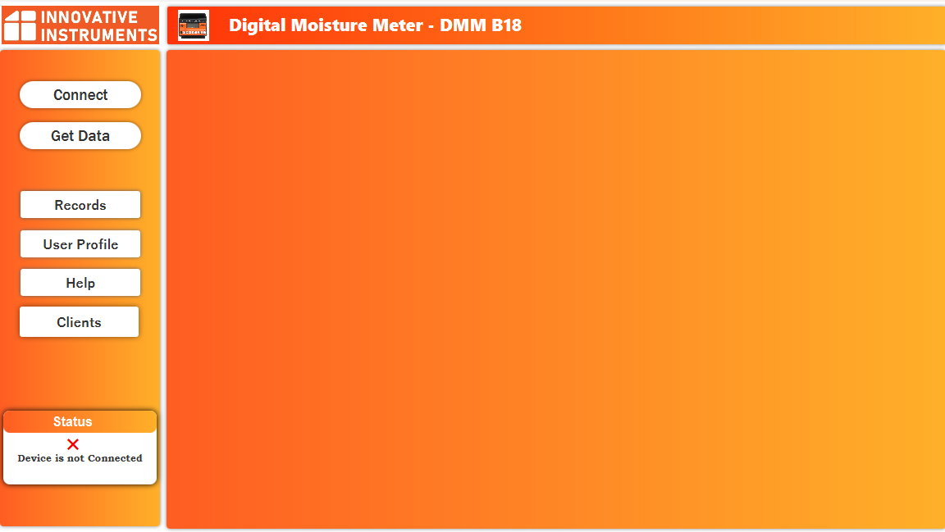

1. **Status window:**

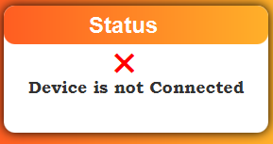

The Purpose of Status window is:-

* To check that device is connected or not connected.
* To track Email sending Progress.

1. **Device Port Connection:**

**Connecting to a Device**

1. Click the **“Connect”** button.
2. A window will appear for **port selection**.
3. Select the port where your device is connected.
4. The device will connect automatically once the correct port is selected.

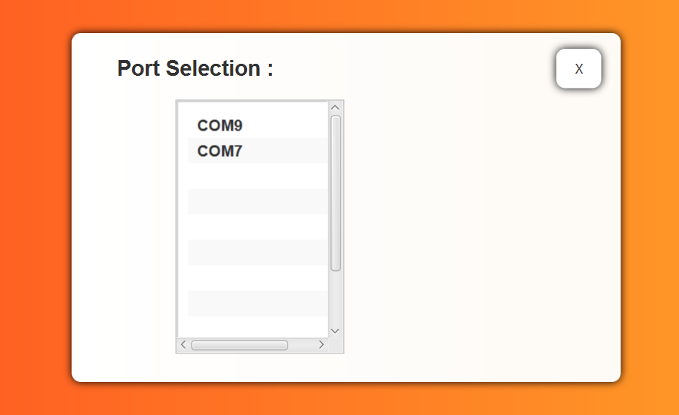

Select device port to Connect.

1. **Receiving and Displaying Data:**

1. Click the **“Get Data”** button to receive the measured data from the meter.

2. The data will be displayed on the application window automatically.

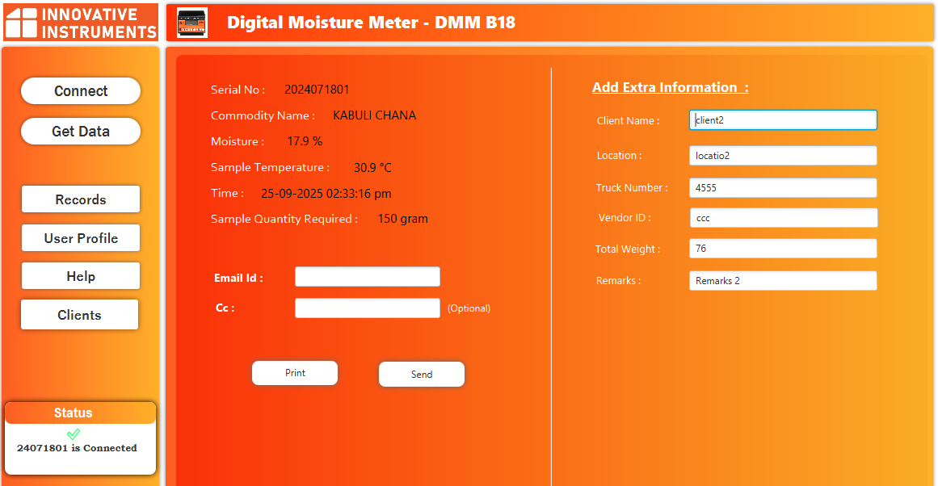

Users can enter additional details such as **Client Name, Location, Remarks**, etc. These fields are available in the **right-side section** of the application window.

**Printing and Sharing Data**

**Print:** Click the **“Print”** button to print the received data. A PDF copy will also be saved at:  
C:\Users\{UserName}\Realogview\DMM1.0\Data\PDF

**Send:** Click the **“Send”** button to share the received data in PDF format.

* Enter the recipient’s **Email Address** before sending.

1. **Accessing Past Records :**

Click the **“Records”** button.

A new window will appear, allowing you to **view and manage past recorded data**.

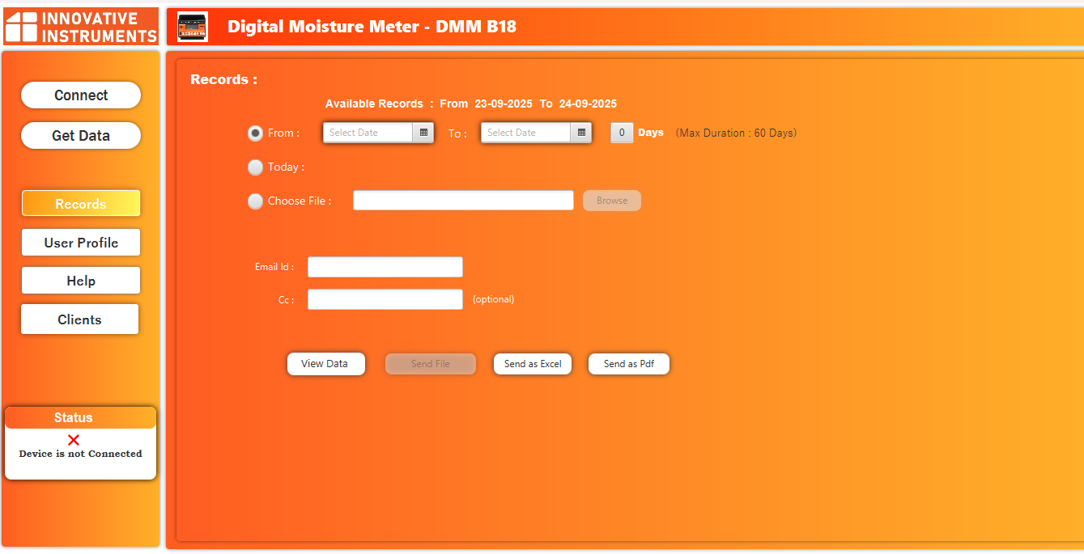

* **NOTE**: The Maximum duration is 60 days for Dates selection.
* **Option 1:**



Select first option to get recorded data, between two particular dates.

* **Option 2:**



Select second option to get today’s all recorded data.

* **Option 3:**



Select third option to choose file.

* After selecting any record or file, the user can **view or share** the data.
* **Send as Excel:** Share the recorded data in **Excel** format.
* **Send as PDF:** Share the recorded data in **PDF** format.
* **Send File:** Use this option to send a **browsed file**.
* **View Data:** Use this option to display recorded data or a browsed file in **table format**.
* The table will show the data clearly for easy viewing.

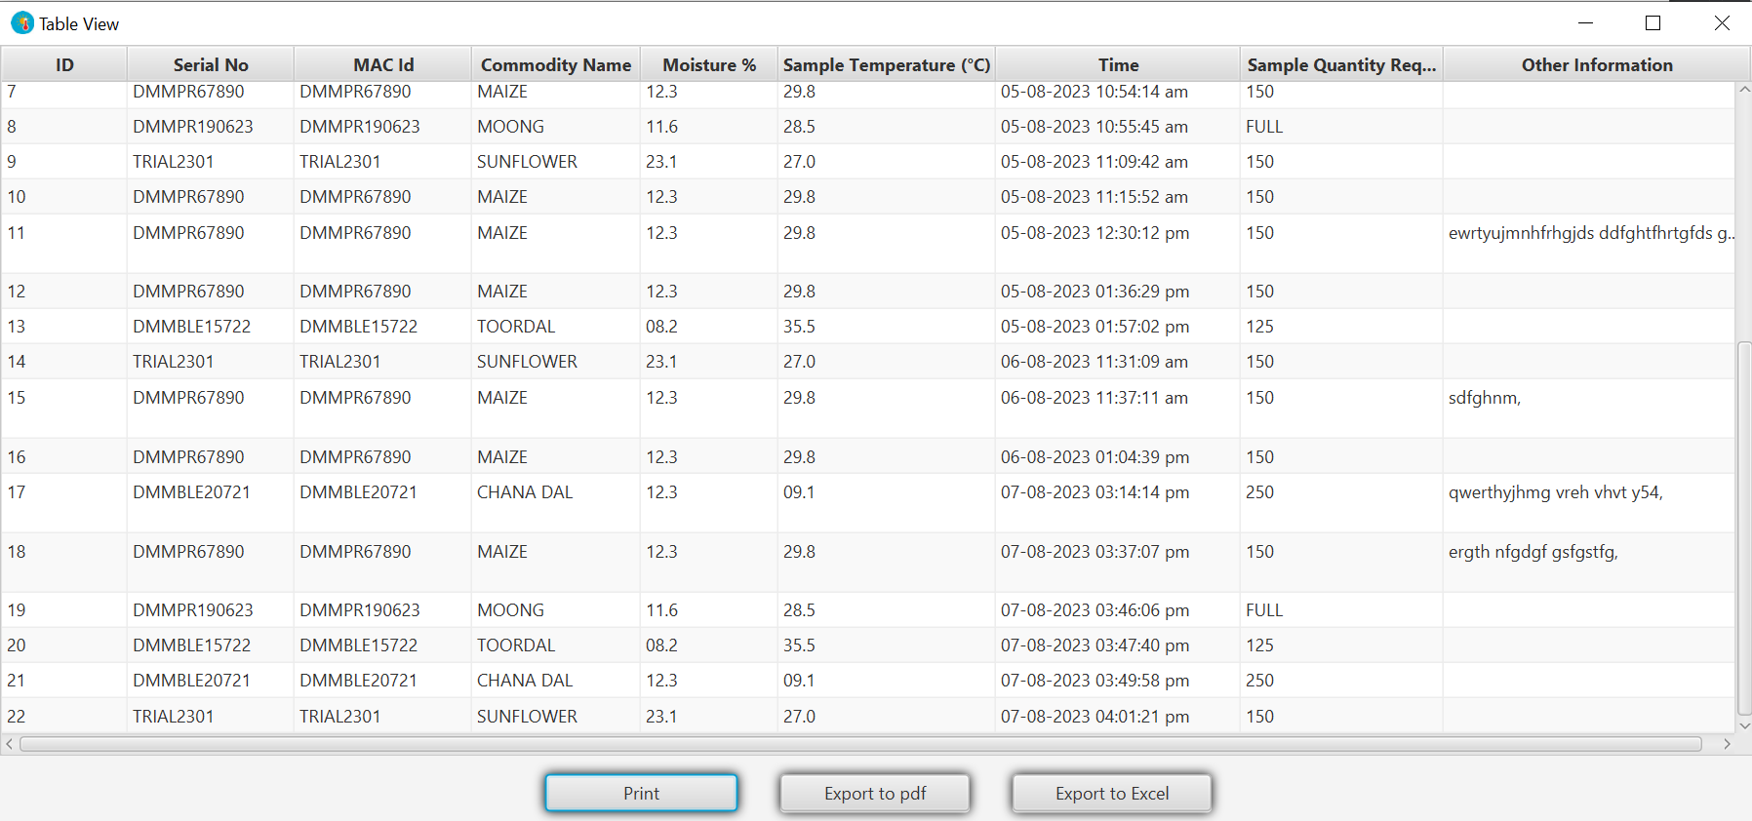

**Print:** Click **“Print”** to print the table.

**Export as PDF:** Click **“Export as PDF”** to save the table as a PDF.

* The PDF will be stored at:  
  C:\Users\{UserName}\Realogview\DMM1.0\Records\PDF

**Export as Excel:** Click **“Export as Excel”** to save the table as an Excel file.

* The Excel file will be stored at:  
  C:\Users\{UserName}\Realogview\DMM1.0\Records\Excel

**Setup User Profile:**

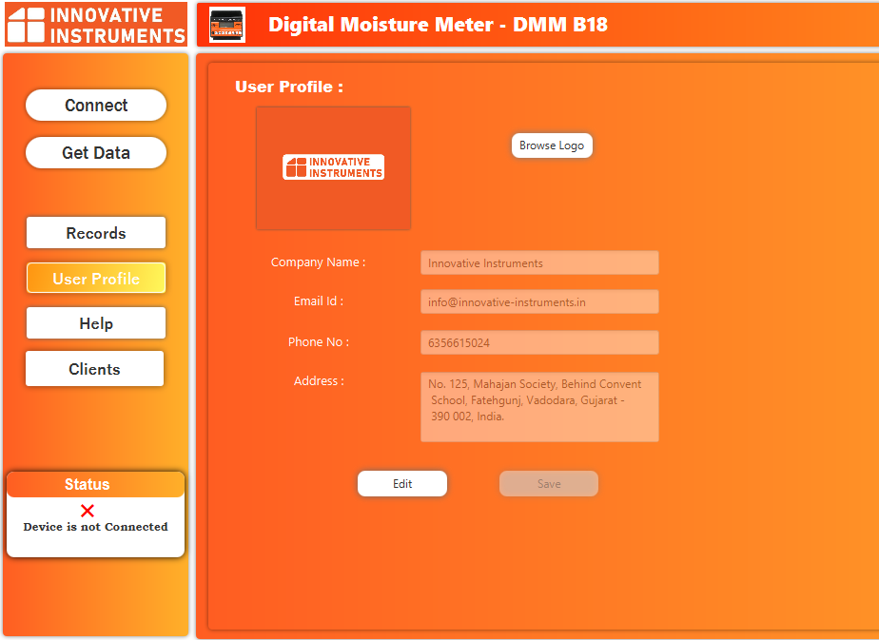

Users can enter their personal or company details in this tab.

These details will be included in the **PDF** and **printed copies** for reference, showing who generated the document.

**Client’s records:**

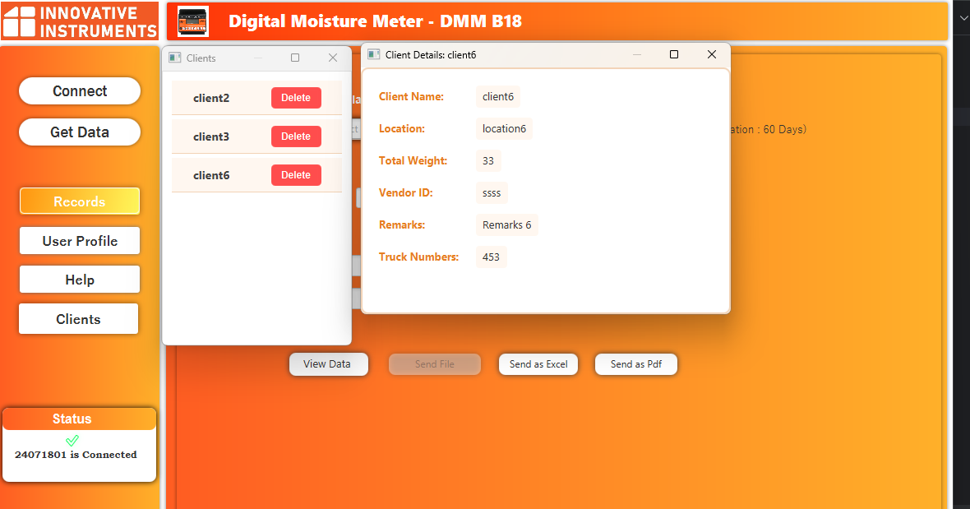

Click the **“Clients”** button to view detailed client information.

To remove a client, click the **“Delete”** button next to their data.

**Help Screen:**

Click the **“Help”** button to access the **FAQ** and **User Guide**.

The FAQ is available in **both Hindi and English**.

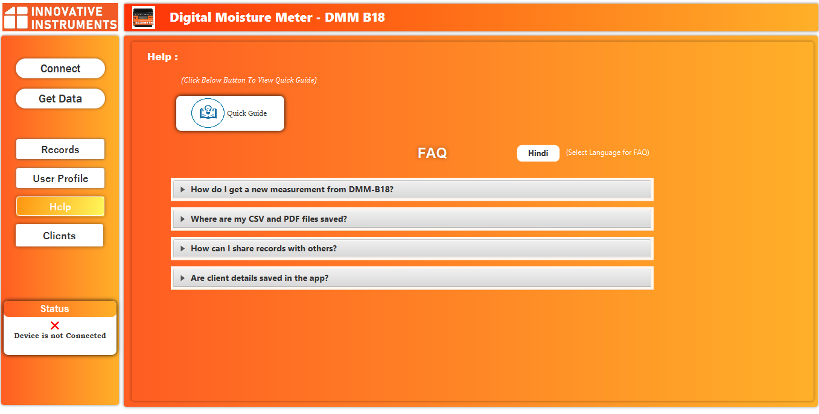

**Note:** By default, the application is pre-filled with information for Innovative Instrument Company.

Users can update the company profile with their own details, including name, address, email, phone number, and logo, as shown above.

**The end**

-------------------------------------------------------------------------------------------------------------------------------------------------------